Name: Math Do Nows Date: May 4 – 8, 2020
Monday | Tuesday | Wednesday | Thursday
Put the number cards in order from least to greatest.  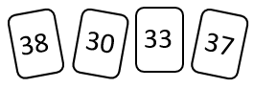  ____ ____ ____ ____ | Name the shape  ____________________  How many?  faces ____ Vertices ____ | Fill in the missing numbers on the number line.  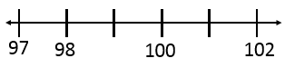 | Cut the circle into halves.
Circle the nail that is 3 paperclips long.  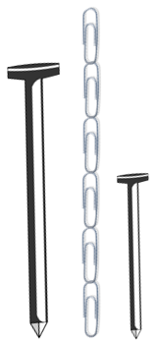 | What time is it?  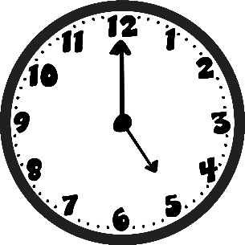  : | Order the nails from longest to shortest.  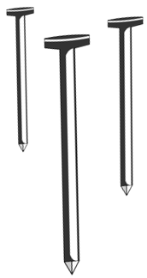 | Draw the hands on the clock to show 3:30.  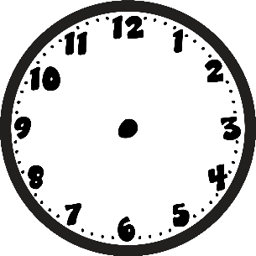
Amy cooked 12 brownies. She ate some, and now has 8 brownies left. How many brownies did Amy eat? | In Emma’s vegetable garden there are 8 carrots, 3 tomatoes, and 5 heads of lettuce. How many vegetables does Emma have in all? | Owen has 15 crayons. 8 of them are broken. How many of Owen’s crayons are not broken? | Each board game costs 5 dollars. How much money do 3 board games cost?
Count by 2’s.  14, 16, 18, ___, ___ | Count by 10’s  80, 90, 100, ___, ___ | Count by 2’s.  54, 56, 58, ___, ___ | Count by 10’s  0, 10, 20, ___, ___
Solve.  4 9 12  + 6 - 7 + 5 | Solve.  11 16 7  + 7 - 8 + 2 | Solve.  5 18 8  + 3 -12 + 7 | Solve.  11 15 12  + 9 -10 + 4
True or False?  7 + 7 = 10 + 4  ________ | True or False?  1 + 8 = 8 - 1  ________ | True or False?  12 - 5 = 8  ________ | True or False?  14 = 8 + 6  ________
Find the missing number.  - + = 18 | Find the missing number.  9 + 6 = | Find the missing number.  7 + = 11 | Find the missing number.  + 9 = 15
Write the number.  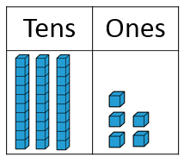  _________ | Draw the number 42.  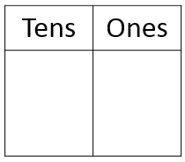 | How many tens are there in the number 75? | How many ones are there in the number 58?
Name: ELA Do Nows Date: May 4 – 8, 2020
Monday | Tuesday | Wednesday | Thursday
Color –igh words blue.  Color –ie words green.  might cries buddies  bright dries light  higher thigh tie |   Write the Correct Long I spelling pattern in the blank  P____  -igh -y -ie |   Write the Correct Long I spelling pattern in the blank  l____ t  -igh -y -ie | Write the Correct Long I spelling pattern in the blank    fr____  -igh -y -ie
Write a word from the box to finish each sentence.  thigh dry  Sam hurt his _______ when he fell. | Write a word from the box to finish each sentence.  try tie  Dad’s ______ has dots and stripes. | Write a word from the box to finish each sentence.  thigh dry  The wet shirt will ________. | Write a word from the box to finish each sentence.  might bright  The light is very _________.
Add -ed and -ing to this word, but first double the ending letter.  pet  -ing __________  -ed __________ | Add -ed and -ing to this word, but first double the ending letter.  run  -ing ___________  -ed ___________ | Add -er and -est to this word, but first double the ending letter.  thin  -er ___________  -est ___________ | Add -er and -est to this word, but first double the ending letter.  big  -er ___________  -est ___________
Correct the sentence then rewrite it.  we are going to amy’s house on Wednesday  ______________________________________ | Add the missing comma, then rewrite it in a sentence.  March 4 2016  ______________________________________ | Correct the sentence then rewrite it.  i invite mark, molly and sally to the party  ______________________________________ | Correct the sentence then rewrite it.  they are going to the park on friday  ______________________________________
Read your Decodable  Sally Jane & Beth Ann  and circle your words with the Long I Spelling Patterns igh, ie, and y and Inflections -ed,-ing, -er, -est, -es.  Then answer these questions in complete sentences.  1.What did Sally Jane like to do at night?  ______________________________________  2. What was wrong with Beth Ann’s wing?  ______________________________________ | Read your Decodable  Ty & Big Gilly  and circle your words with the Long I Spelling Patterns igh, ie, and y and Inflections -ed,-ing, -er, -est, -es.  Then answer these questions in complete sentences.  1.What was Ty’s fishing box filled with?  ______________________________________  2. Who is Big Gilly?  ______________________________________ | Read your Decodable  Bird Watching  and circle your words with the Long I Spelling Patterns igh, ie, and y and Inflections -ed,-ing, -er, -est, -es.  Then answer these questions in complete sentences.  1.What is shiny on the bird?  ______________________________________  2. Which bird can swim but not fly?  ______________________________________ | Read your Decodable  Benches  and circle your words with the Long I Spelling Patterns igh, ie, and y and Inflections -ed,-ing, -er, -est, -es.  Then answer these questions in complete sentences.  1.Where do you see benches?  ______________________________________  2. What can you do on benches?  ______________________________________

